Appointed Representative

User Guide

for

Access to the Electronic Folder



August 2018
Table of Contents

ARS Overview 2
Requirements for Access to the Electronic Folder 2
Logging into Appointed Representative Services 2
Navigating Appointed Representative Services 3
ERE Home Page 3
ERE: Electronic Folder 5
Case Documents Tab 5
Exhibit List Tab 6
Multimedia Files Tab 6
Display Options 7
Selecting Documents 7
Downloading Documents 8
Pick Up Files 8
Viewing ZIP Files 10
Viewing PDF Files 11
Viewing Multimedia Files 11
FTR Instructions 12
OGG Vorbis Instructions 16
Uploading Documents 16
Track Status of Submissions 19
Get Status Reports 19
Contact OHO Office 20
Manage Your Email Notifications 20
Logging Out of ERE 21
Troubleshooting Common Problems 21
Unable to Access an Electronic Folder 21
eFolder Service Suspended 21
Unable to Process Your Request 21
Timing Out 22
Avoiding User Errors 22
ERE Electronic File Format Options 22
Glossary 23

ARS Overview

This guide provides Social Security Administration (SSA) claimants’ appointed representatives with detailed instructions for viewing and downloading documents in their claimant’s electronic folder. It also provides guidance on submitting evidence in electronic format (e.g., briefs and additional disability-related evidence) using the upload feature inside the claimant’s electronic file.

Requirements for Access to the Electronic Folder

- You must have a User ID and a self-selected password;
- The claimant’s file must be electronic at the Hearing or Appeals Council level; and
- The link Access Claimant’s Electronic Folder must be displayed on the Electronic Records Express (ERE) home page under the Electronic Folder Functions section.

Logging into Appointed Representative Services

Log into Business Services Online at https://secure.ssa.gov/acu/LoginWeb/loginHandler.do?SUITE=AR

NOTE: You must open a single browser session to log into the Appointed Representative Services to access electronic folders. After login, DO NOT open multiple browser sessions to open electronic folders and review or download files.

The User ID and password for the Appointed Representative Services cannot be used on other SSA website login pages. The login will fail and be considered an invalid attempt. After a certain number of invalid login attempts, your User ID will be suspended.

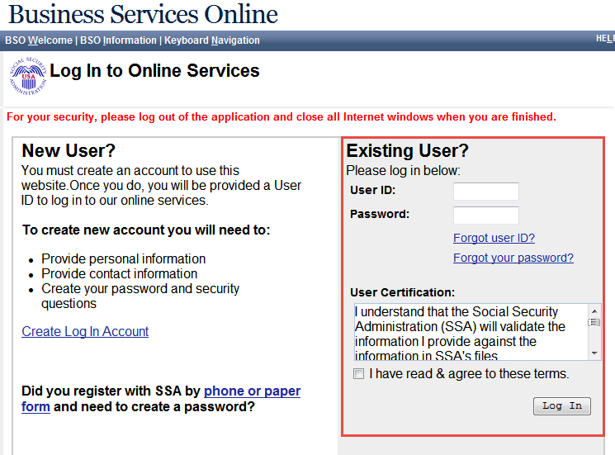

Navigating Appointed Representative Services

The ARS main menu displays information about ERE authorized services, Appointed Representative registration, and account management.

- Select Enter ERE

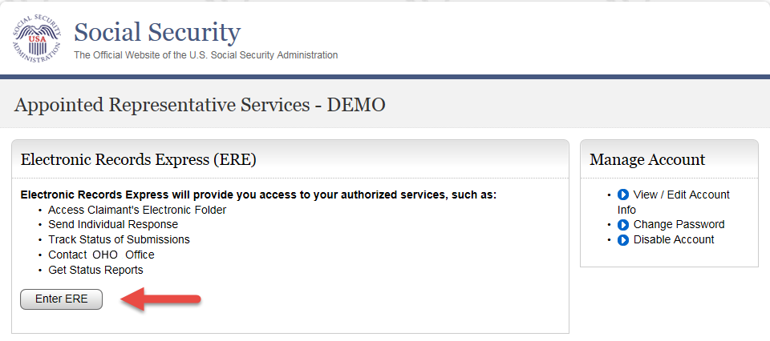

ERE Home Page
- To access the folder, select the Access Claimant’s Electronic Folder link in the Electronic Folder Functions section.

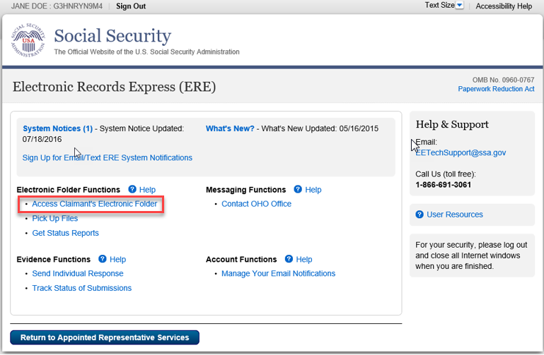

- You will receive a one-time password on the text-enabled cell phone number you provided during registration.
- Enter the one-time password.

NOTE: Delete the text message after it is used. The one-time password is temporary and is valid for only 10 minutes. Undeleted text messages may be repeated in a future text message.

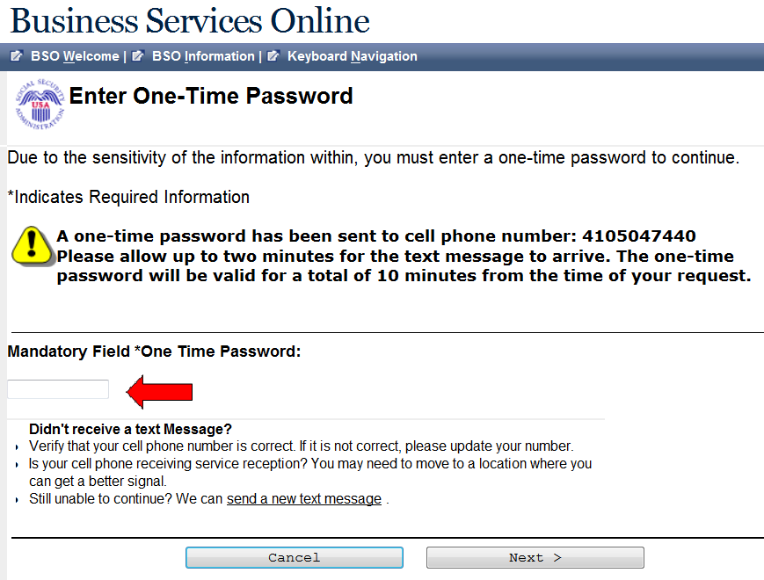

- Read the Acknowledgement for Online Services agreement before entering the Claimant’s Social Security Number (SSN). Select the I Agree button.
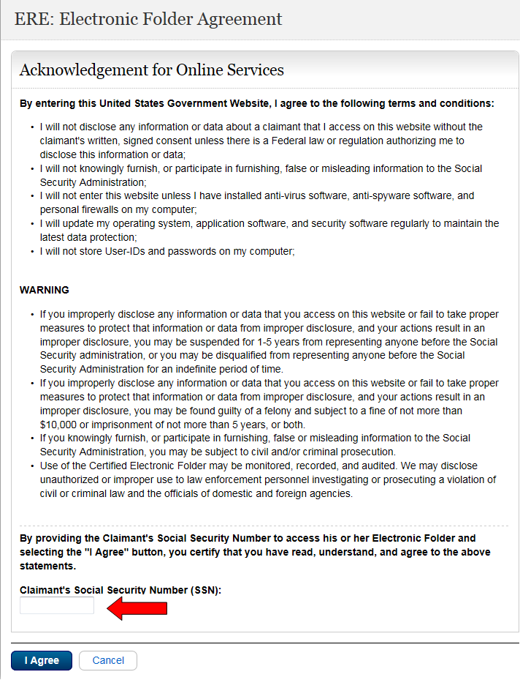

ERE: Electronic Folder
The ERE: Electronic Folder screen contains a header and three tabs: Case Documents, Exhibit List, and Multimedia Files.

The folder initially displays with all the documents hidden.

Case Documents Tab
Case Documents tab provides the ability to view all documents in these sections of the eFolder:
- Section A - Payment Documents/Decisions (Yellow)
- Section B - Jurisdictional Documents and Notices (Red)
- Section D - Non-Disability Development (Orange)
- Section E - Disability Related Development (Blue)
- Section F - Medical Records (Yellow)

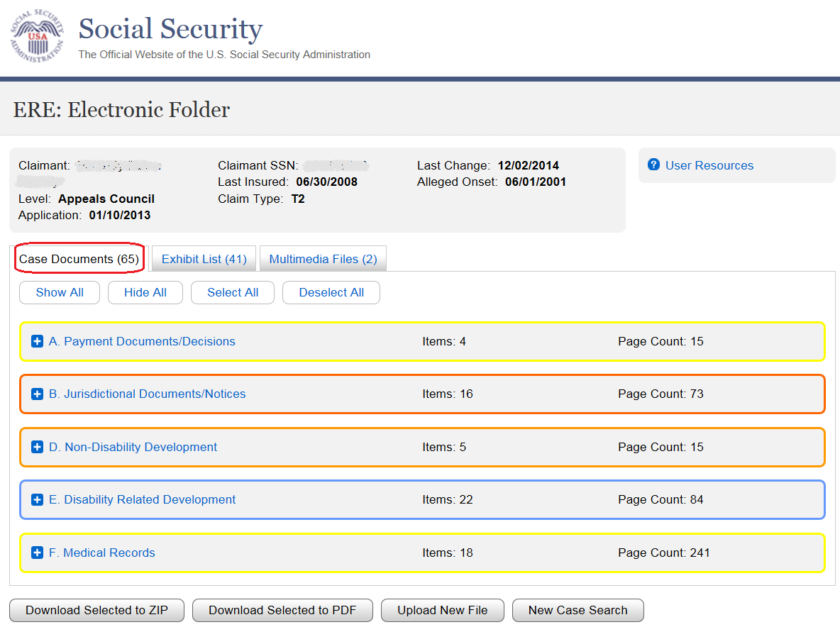

Exhibit List Tab
The Exhibit List tab provides the ability to view all the exhibited documents. The sections are the same as those in the Case Documents tab above but all sections have a gray background.

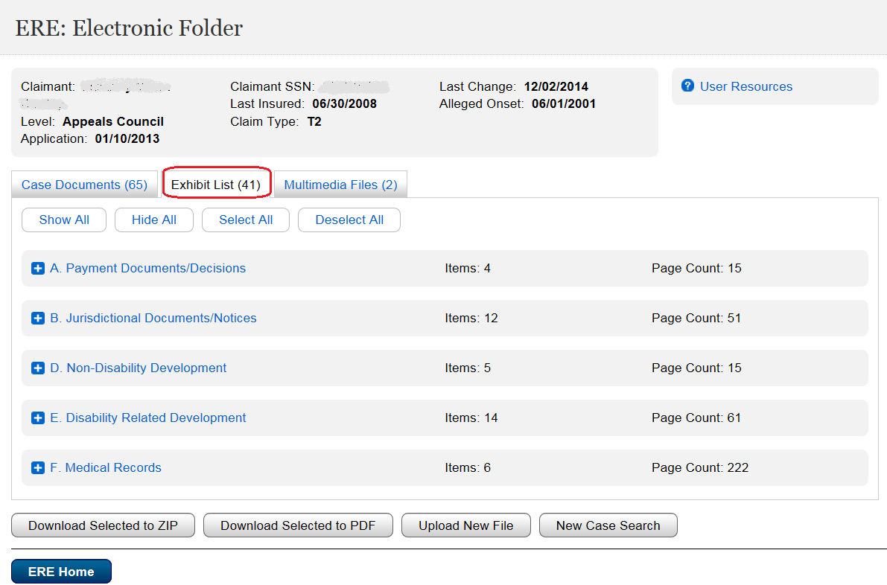

Multimedia Files Tab
The Multimedia Files tab provides the ability to view all the multimedia files. This tab only displays when a claimant’s eFolder contains multimedia content. One section displays with a gray background.

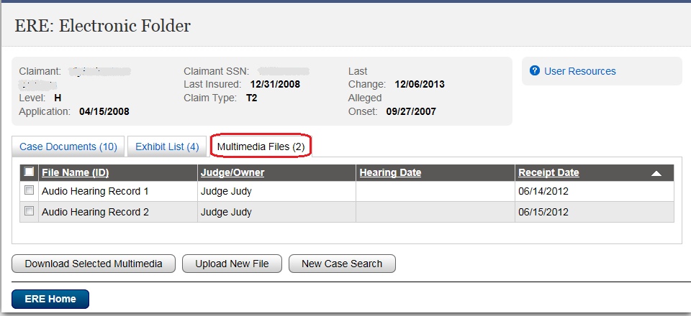

Display Options
Show All/ Hide All - Select the Show All button to view all documents in the file. Select the Hide All button to close all sections.
Show/ Hide by Section– To the left of each section name is a blue square. Selecting the plus sign causes that section to open and display the documents in the section. Selecting the minus sign causes that section to close.

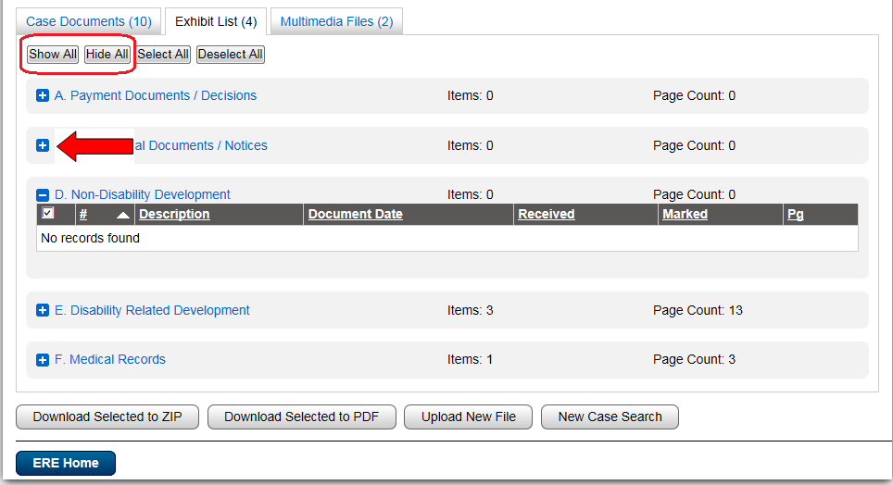

Selecting Documents
Select All/ Deselect All - Selecting these buttons mark or unmark all documents. The checkmark next to the document indicates a selected document.

Select/ Deselect individual documents – Select/ deselect individual documents by checking/ unchecking the box next to the document description.

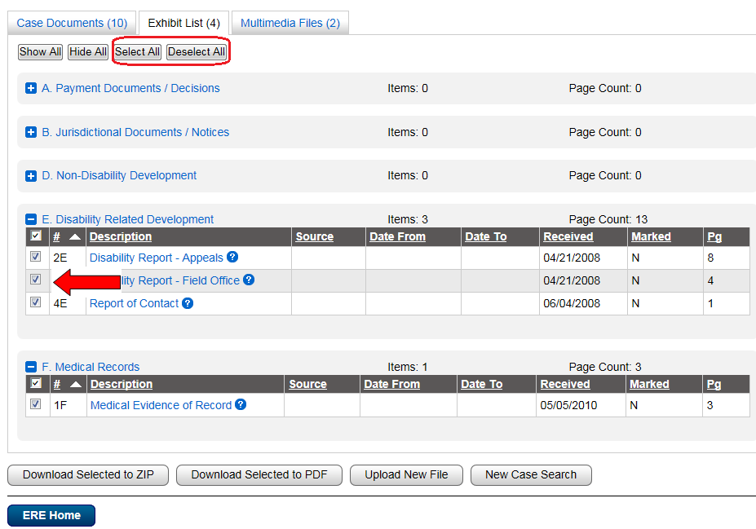

Downloading Documents
You can open documents immediately or select them for download. You can choose to download documents to either a ZIP or PDF file.

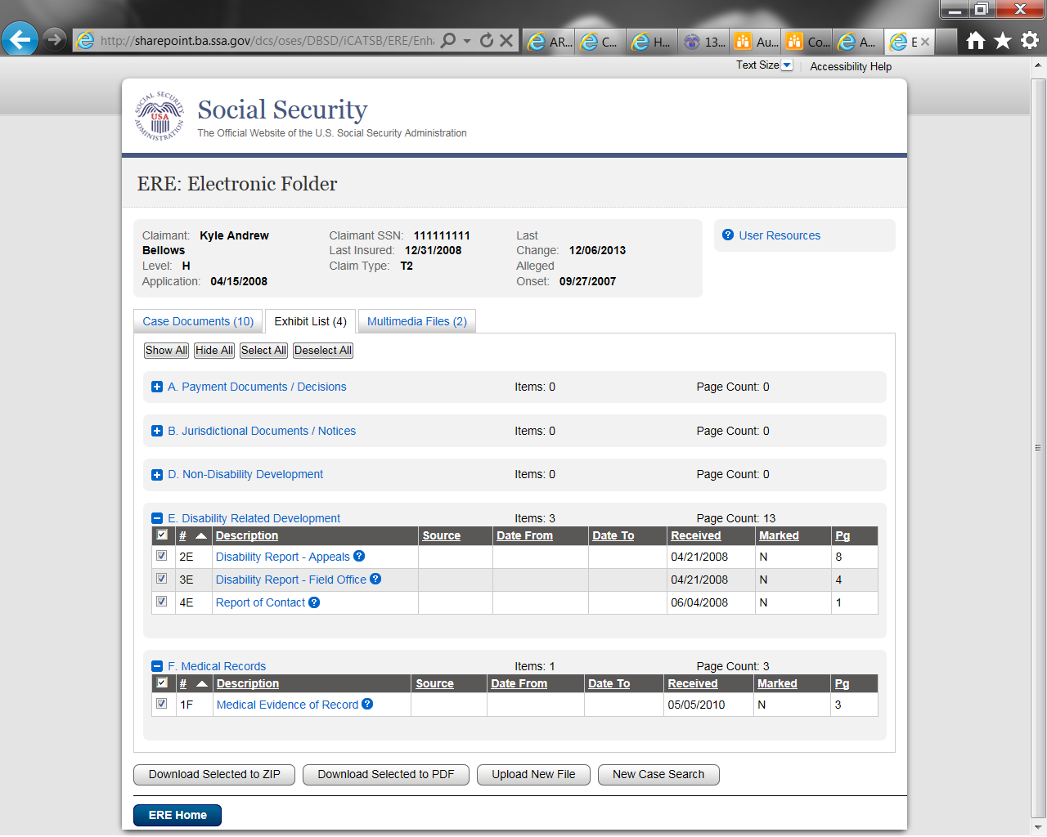
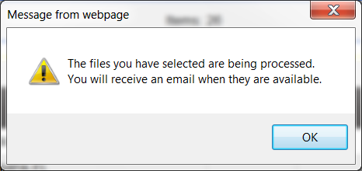

Pick Up Files
- Within approximately 48 hours after downloading, the files are available for pick up.
- An email message will be sent to you when the requested files are ready or if the download was unsuccessful.
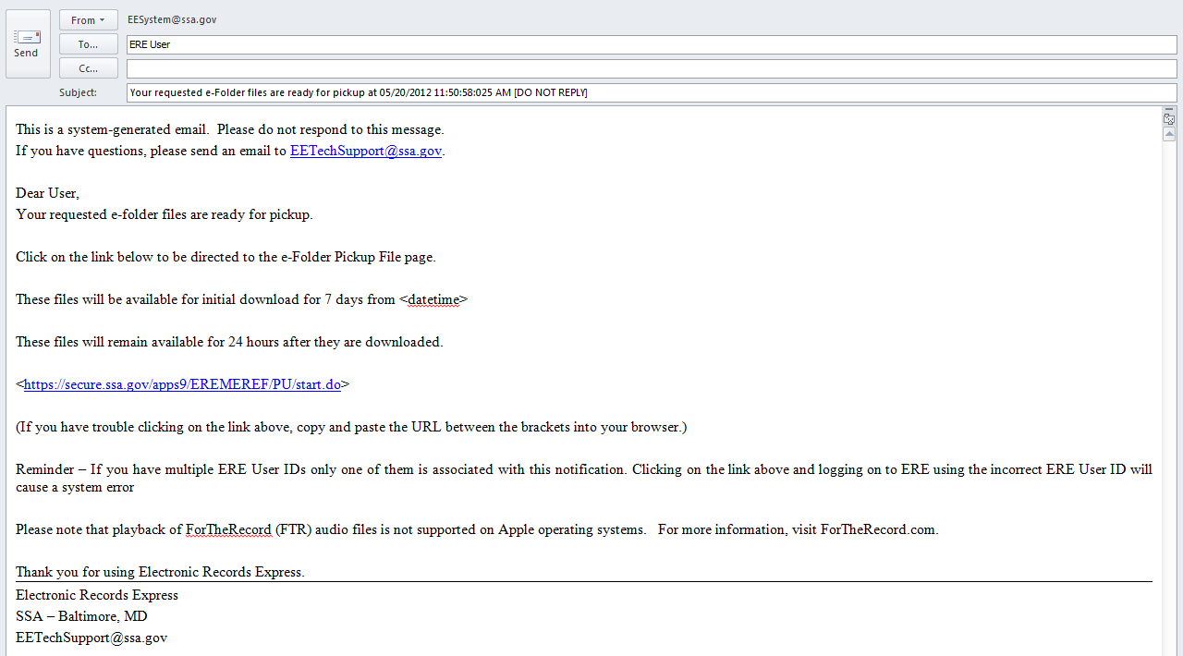
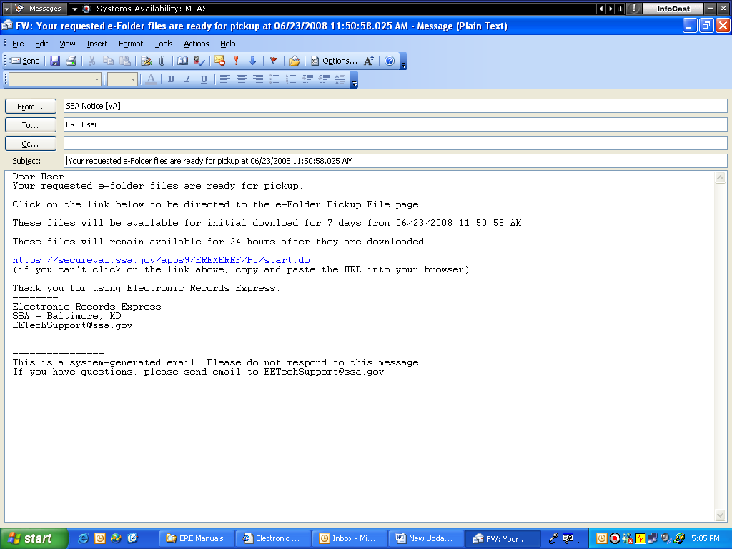

- The link in the email will take you to the ERE login.

- Follow login instructions then enter the One-Time Password that generates to your text-enabled cell phone.

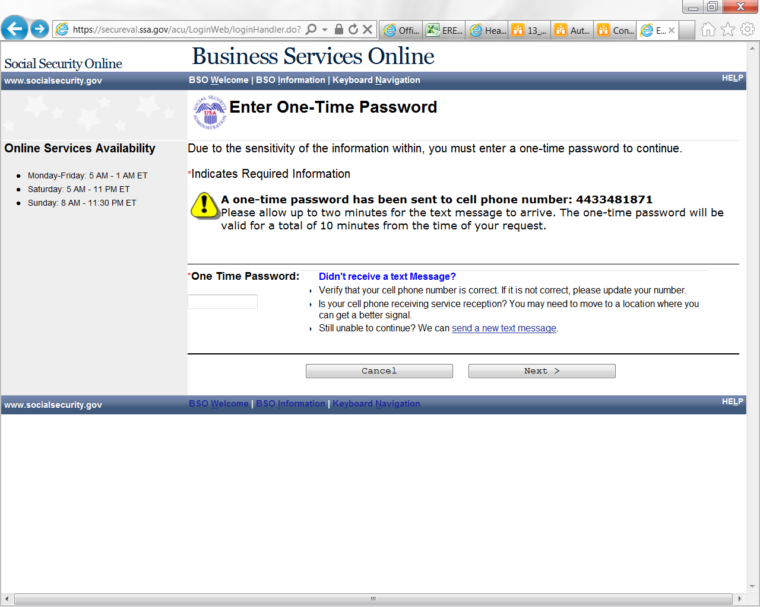

- On the ERE home page, select Pick Up Files link in the Electronic Folder Functions section.

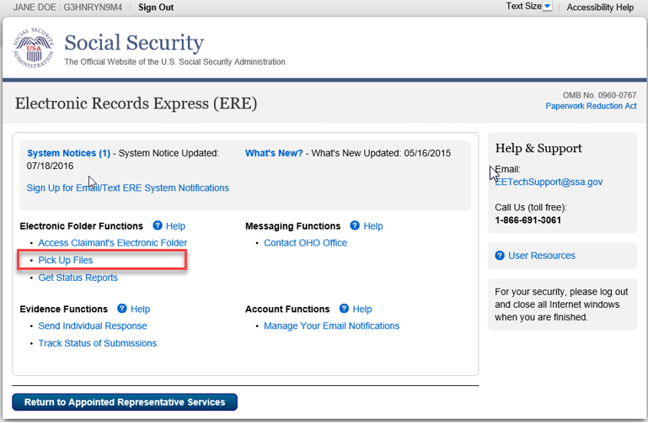

- Select the claimant’s SSN (Last 4) link to download the file you requested.
- A message box will display; Save the document to a desired location on your computer.

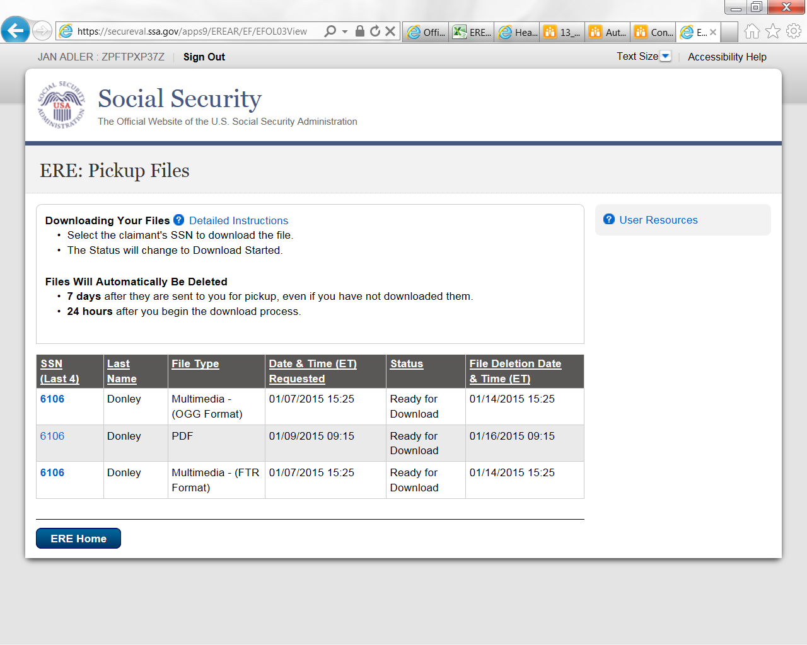
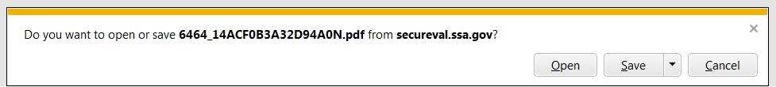

Viewing ZIP Files

- Go to the location where you saved the ZIP file and double click on the file to open it.
- On the WinZip toolbar, select Extract.
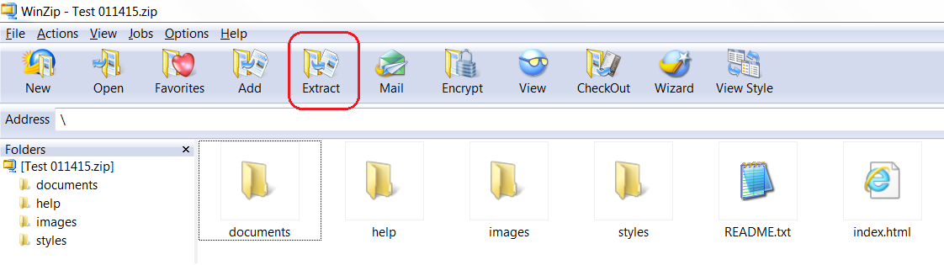

- Save all the files/folders in the ZIP file package to the desired location on your computer.
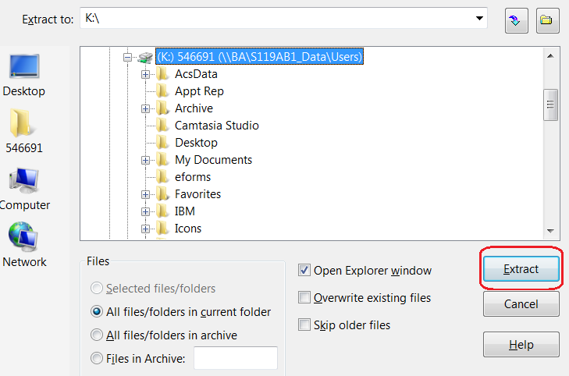
- To view the documents, go to the location where you extracted the files and select the index.html file.

Viewing PDF Files

- Go to the location where you saved the PDF file and double click on the file to open it.

Viewing Multimedia Files

OHO has two types of audio files: ForTheRecord (FTR) files that require “TheRecord Player” audio player and Jefferson Audio Video Systems (JAVS) files that can be played on multiple platforms or using the JAVS player. If you do not have these players, you may download either of them free of cost following the instructions outlined below.

SSA File Formats

SSA supports the following audio file formats:
- TRM - ForTheRecord file format (FTR audio)
- OGG - OGG Vorbis file format (JAVS audio)

Determining the File Format Downloaded and Player Needed

- Go to Pickup Files and download the folder to your computer.
- Open the folder.
- You may have to extract the contents to a location on your computer.
- Go to the location where you extracted the files and click on them to open.
- Determine the type of player needed for audio:
  - If a folder labeled Media displays, refer to the OGG Vorbis Instructions
  - If no Media folder displays, refer to the FTR Instructions.

Multimedia Index
In order to play the FTR digital recordings, you must have the ForTheRecord "TheRecord Player" audio player installed on your computer. If you do not have TheRecord Player, you may download it free of cost.

OGG audio files can be played on multiple operating platforms (Windows, MAC OS, Unix/Linux). FTR audio files are not supported on Apple operating systems.
Please go to the ForTheRecord website to ensure that you have the minimum system requirements for downloading "TheRecord Player."

FTR Instructions

Download the FTR Player:
- Go to the For The Record website: www.fortherecord.com
- Verify that minimum system requirements are satisfied
- Click on Products
- Select The Player
- Click on Download FTRPlayer
- Click to run the setup
- Follow the prompts and standard instructions to complete the installation.

For more information on the FTR Player setup, please visit www.fortherecord.com.

Configuring FTR Player: Search Folders
NOTE: The FTR Player requires setting up the Search Folder path prior to playing the audio.

- Click Start (the Windows icon in the left hand corner of your desktop); select All Programs, then ForTheRecord and TheRecord Player.

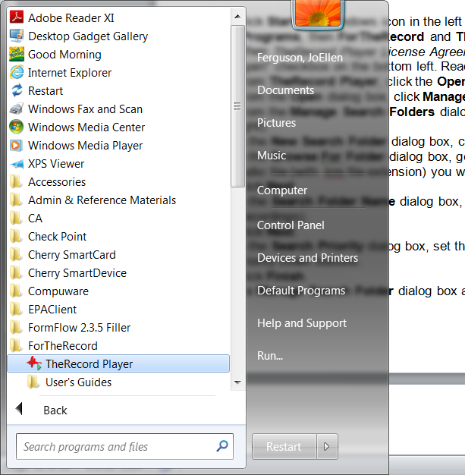

- When TheRecord Player License Agreement appears, select the "Don't show this screen again" checkbox on the bottom left. Read the agreement then click the "I Agree" button.

- From TheRecord Player, click the Open icon (first icon on the bottom).

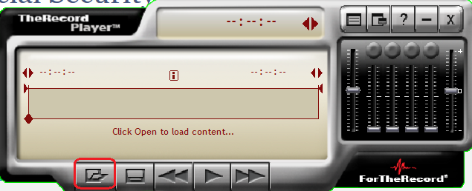

- From the Open dialog box, click Manage Search Folders icon (second icon in the top left).

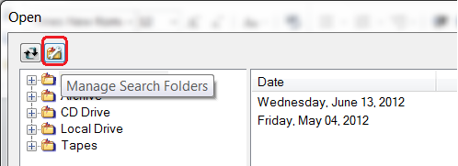

- From the Manage Search Folders dialog box, click Add Search Folder (first icon on the right).
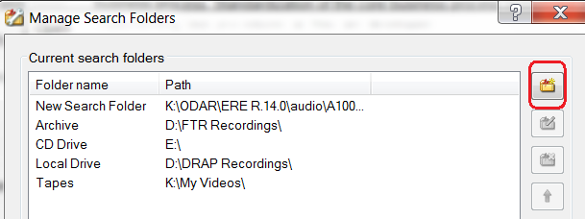

- In the New Search Folder dialog box, click Browse.

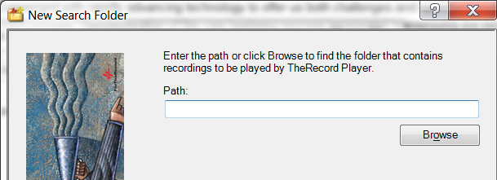
- In the Browse For Folder dialog box, go to the folder that contains the audio file, select the audio file (with .trm file extension) you wish to add and click OK.

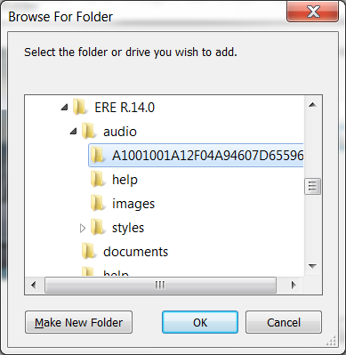

- Click Next.
- In the Search Folder Name dialog box, enter a user-friendly name (ex. Archive Recordings).
- Click Next.

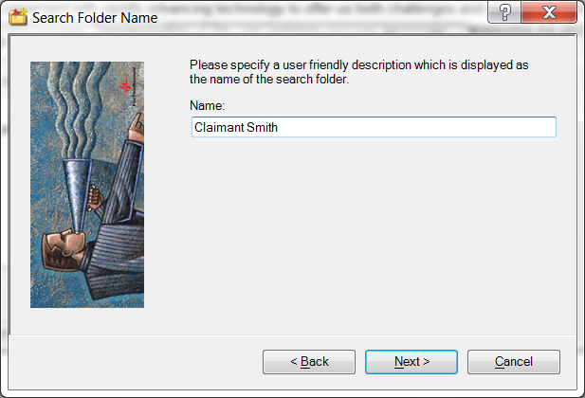

- In the Search Priority dialog box, set the search priority by clicking the Priority Up and Priority Down buttons.

- Click Finish.

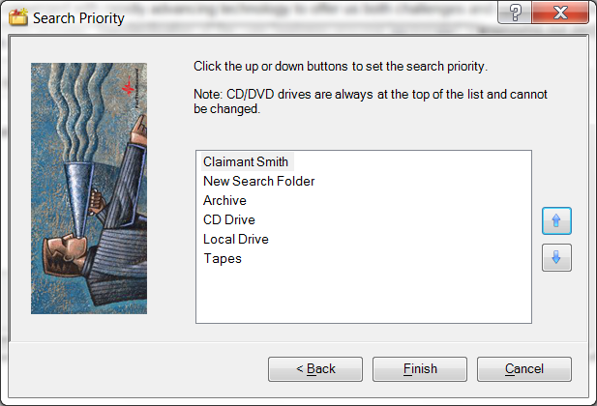

- If a Manage Search Folder dialog box appears, click Close.

Note: Having multiple search folders can be helpful when attempting to download and play previously downloaded audio. Adding the same audio file, that was previously downloaded to the same folder, could potentially compromise audio quality.

Extracting ZIP File Contents

- Extract all files in this ZIP File package and verify that "Use folder names" is selected.
- Save the file in your desired location.
- Go to the location where you saved the file.
- Locate and open the Audio folder.
- Locate and move the Audio file (the file has a trm file extension) to the search folder specified using the Configuring FTR Player - Search Folders instructions above.

Playing the Audio Files with the FTR Player

Once you extract the ZIP file and setup the Search folders, follow the instructions below to play the audio file:
  - Click Start (the Windows icon in the left hand corner of your desktop); select All Programs, then ForTheRecord and TheRecord Player.
  - From TheRecord Player click the Open icon (first icon on the bottom).
  - From the Open dialog box, locate the multimedia file by clicking the plus sign beside the desired Search Folder; then click the plus sign beside the desired date.
4. Once the multimedia file is revealed (where media type contains .trm file), select it and click Open button.
5. Select the Label and click pen.
6. Click Begin Playback on TheRecord Player.

For more information on the FTR Player setup, please visit www.fortherecord.com

OGG Vorbis Instructions

Once you extract the ZIP file to a desired location on your computer, follow the instructions below to play the audio file:

Open the Media folder and open each .ogg file individually. If audio does not play, follow the instructions below to download an OGG Vorbis compatible Player/Codec, and try opening the .ogg files again.
- Go to the www.vorbis.com website.
- Select the platform for your operating system.
- Follow instructions under the Playback section for download and install options for playback of ogg vorbis files.

Uploading Documents
Once inside the electronic folder, upload new documents by selecting the Upload New File button.

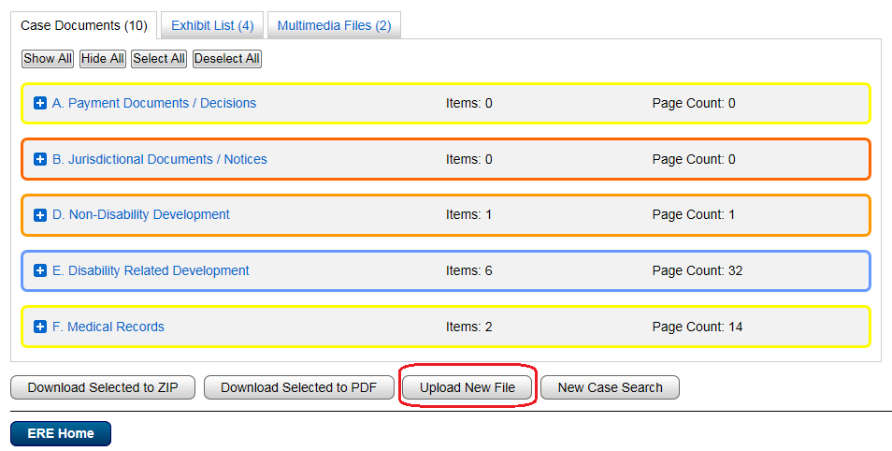

The Upload New File button transfers you to the Send Individual Response screen.

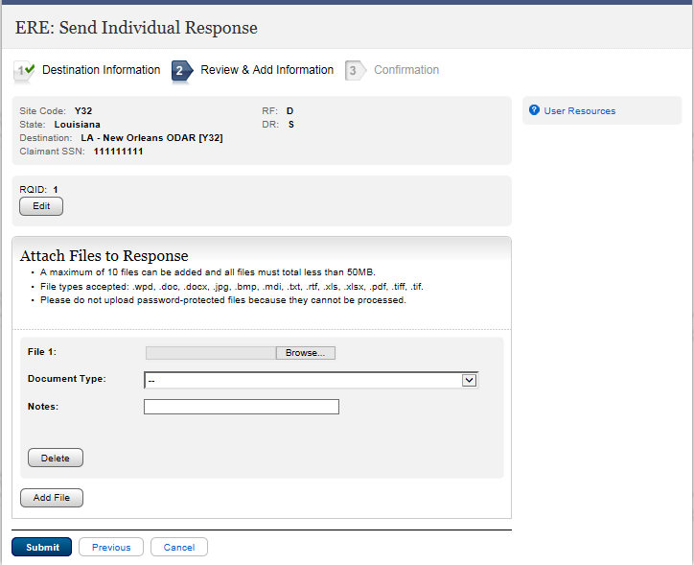

Select Browse to locate file you wish to upload. Choose the Document Type from the drop down menu and add any additional notes about the file you are uploading. Press Submit.

The following screen is generated and provides the tracking information of the file recently uploaded.

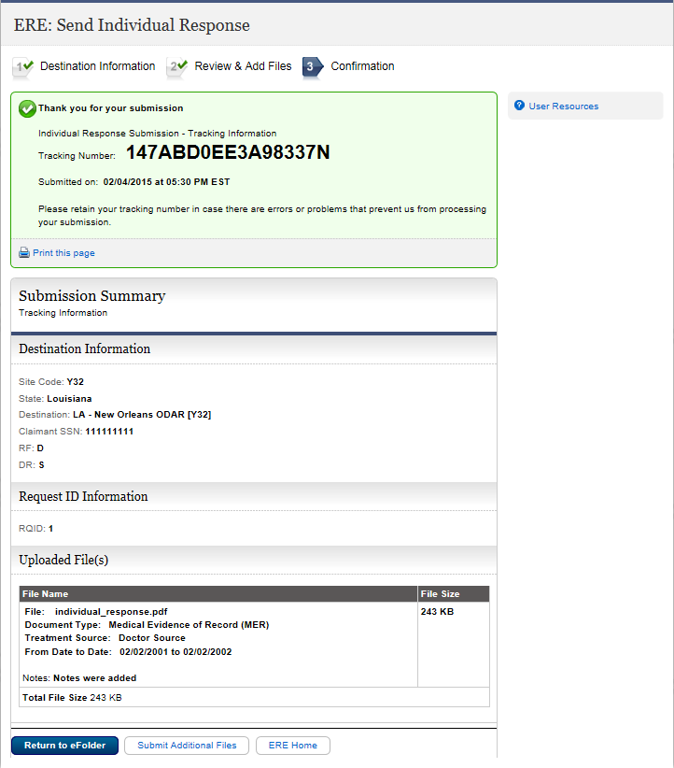

If you have files to load for an additional claimant select Submit Additional Files.

Track Status of Submissions
This feature allows you to view the status of your submissions. You can select from multiple search criteria. However, ERE can only supply information about submissions within the past 180 days.

Follow the Track Status of Submissions User Guide in the User Resources.
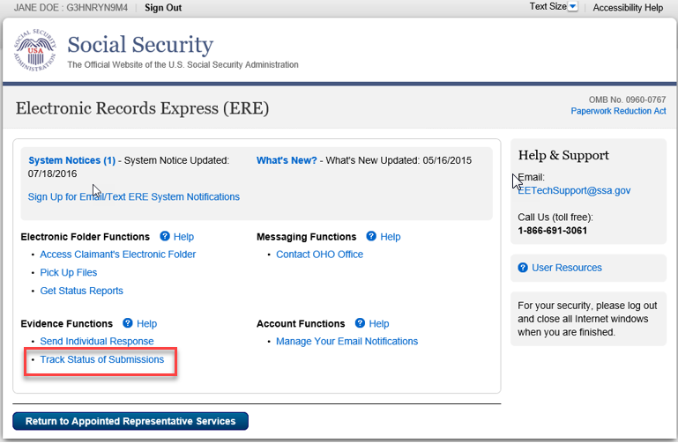

Get Status Reports
This feature allows you to view information on cases pending at the Hearing Office and Appeals Council. You can select from multiple search criteria.
Follow the Get Status Reports User Guide in the User Resources.

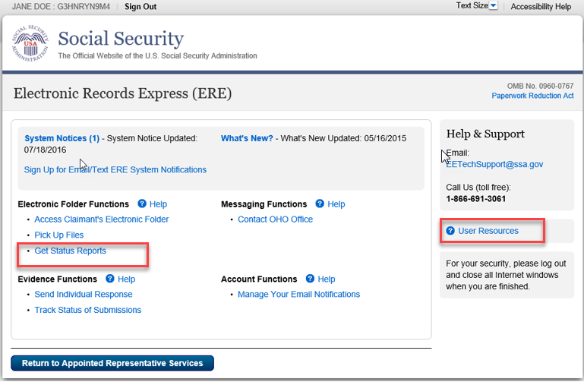

Contact OHO Office
This feature allows you to send a secure, one-way communication to a specific Hearing Office. Communications using this feature should be non-case related, such as change of address for a representative or a representative’s schedule.
Follow the Contact OHO Office User Guide in the User Resources.

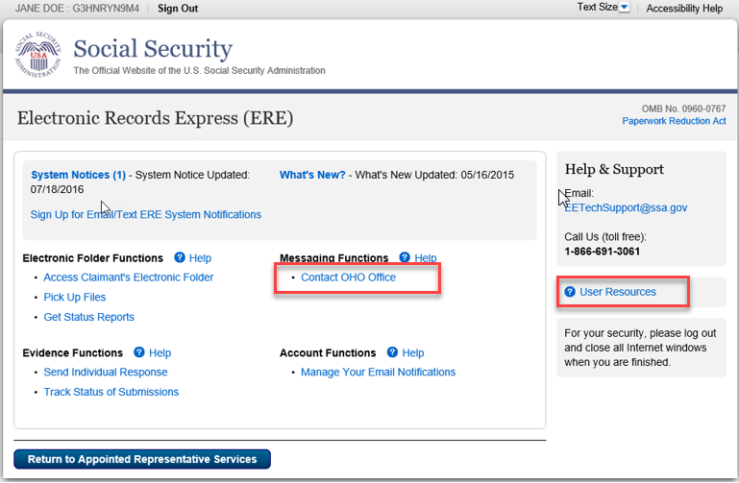

Manage Your Email Notifications
This feature allows you to turn off your automatic email notifications when files are ready for pickup.
Follow the Access Claimant’s Electronic Folder/ Pickup Files User Guide in the User Resources.
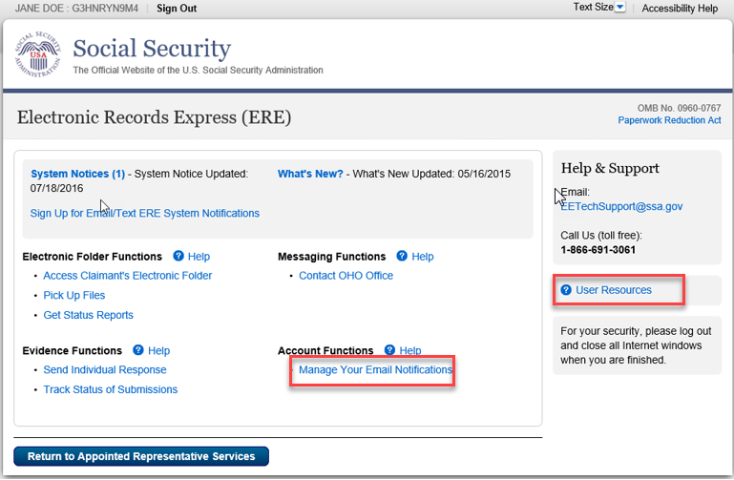

Logging Out of ERE
To end your session, select the Sign Out button. This button is located on the upper left of most pages. For some screens, you may have to return to ERE Home to log out.

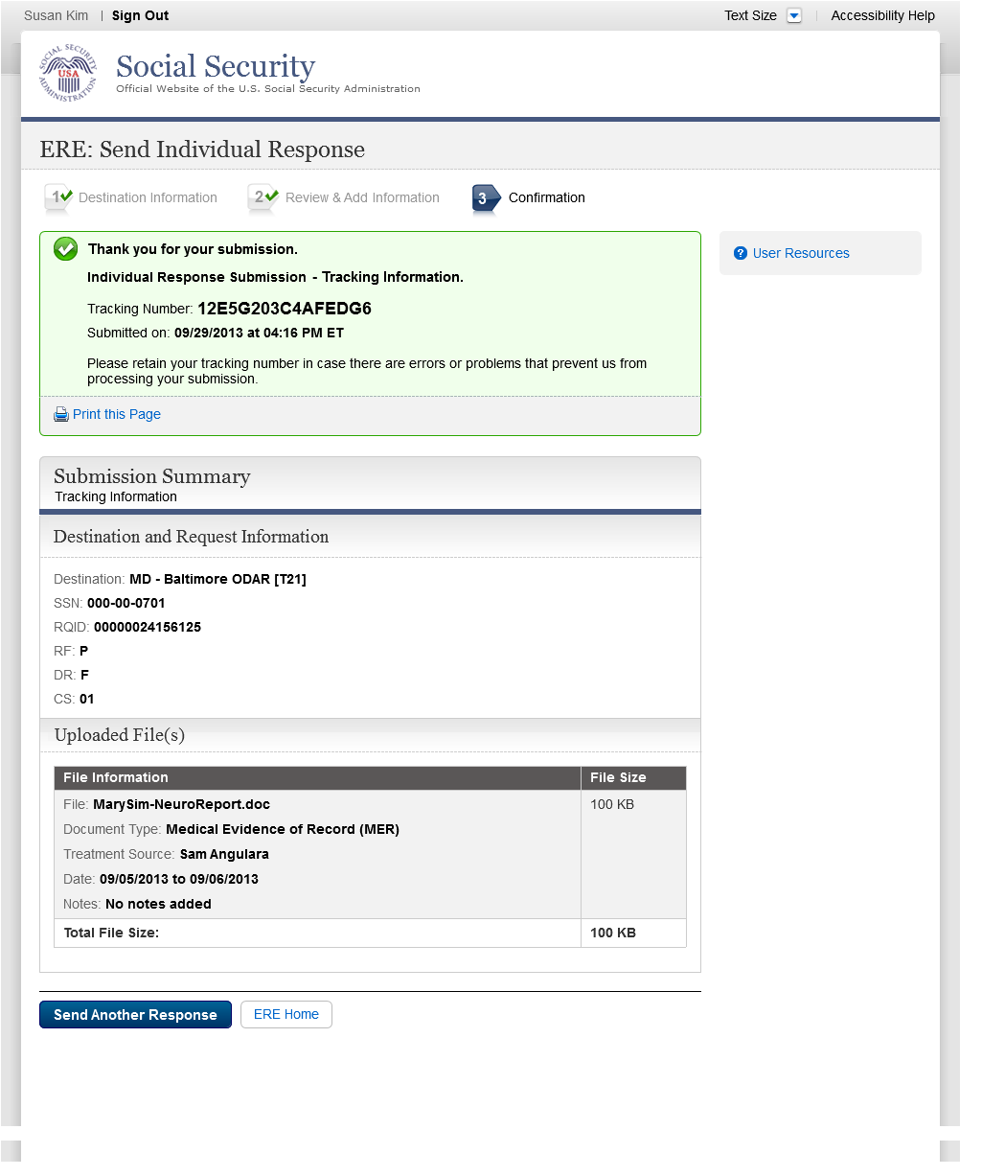

Troubleshooting Common Problems

Unable to Access an Electronic Folder
There may be occasions when you request access to an electronic folder and the request cannot be processed. If your request cannot be processed, you will be presented with an Access Denied message or an Unable to Process Your Request message.

These messages may be received for a number of reasons:
- You may have entered the wrong claimant SSN. Double check the number before you request access a second time.
- The case may not be at the Hearing or Appeals Council Level (you can only view cases at the Hearing or Appeals Council Level).
- The case may have closed at the Hearing or Appeals Council Level. Access is only available for a limited time (90 days) after a decision is issued.
- You may not be listed as the appointed representative for that claimant.

eFolder Service Suspended
You will receive this message if you attempted to view 10 claimant SSNs that were denied access within a 24-hour period. Once you receive this message, if you wish to continue accessing eFolders, you must call 1-866-691-3061 and ask to be reactivated.

Unable to Process Your Request
You may receive this message because:
- The case may not be electronic,
- The case may have closed at the Hearing or Appeals Council Level. Access is only available for a limited time (90 days) after a decision is issued.
- The case may have been remanded, or
- There are multiple cases pending or closed within the past 90 days at SSA and the system cannot determine which one to display.

You must contact the Social Security office handling the case for additional help.

Timing Out
The website will time out after 30 minutes of inactivity. After 2 hours, the website will log you out and you must re-enter your User ID and Password to continue.

Avoiding User Errors
Errors can occur for many reasons. The following list briefly explains some common ERE website user errors:
- Bookmarking the Confirmation page – Never bookmark pages within the ERE website. The only bookmark you should use for the ERE website is the home page at http://eme.ssa.gov.
- Once you have submitted documents by selecting the Submit button, you should NOT use the Back button or close your Internet browser file until you receive the Confirmation page.

ERE Electronic File Format Options
The ERE website currently supports the following file formats:
.wpd | .doc | .txt | .xlsx | .mdi
.pdf | .xls | .jpg | .docx
.bmp | .tiff | .tif | .rtf

Glossary

Acceptable File Type: Types of files that are compatible with a given computer program or website. The ERE website currently supports the following type of files: wpd, .doc, .docx, .jpg, .bmp, .mdi, .txt, .rtf, .xls, .xlsx, .pdf, .tiff, and .tif.

Barcode: A 2-D barcode determines the ultimate destination (paper folder and/or electronic folder) for the evidence submitted (uploaded). The 2-D barcode acts as a portable database to store the following information: Social Security Number (SSN), RQID (request ID) number, site number (DDS or OHO), and document type (e.g., Medical Evidence of Record, Activities of Daily Living). The RQID is SSA’s/OHO’s unique transaction tracking number, and when received, can be used to generate a tickle in the case processing system. If a Representative fails to submit the bar-coded information, the document must be manually indexed at the OHO.

.bmp: The filename extension for a bitmap file. Bitmap is a common graphic format used by computers. A graphic or picture is made up of a number of individual dots (bits) to form an image. A bitmap is essentially a map of bits (hence the name). Bitmap files can get very large and if storage space is a factor then it is best to convert the image into a more compressed format such as .jpg.

.doc or .docx: The filename extension for a Microsoft Word document file. “.Docx” is the extension of files created in Microsoft Word 2007 or higher.

Download: The process of transferring a file from a remote computer, server, or webpage to your own computer. Download is the opposite of upload.

ERE - Electronic Records Express: SSA’s secure website used primarily for uploading (sending) electronic medical and other evidence considered in determining disability eligibility.

e-folder (eFolder): The electronic disability folder (e-folder or EF) is SSA’s electronic disability repository of data that is accessible by all components involved in the processing of disability claims. Data housed in the e-folder comes from many different SSA and OHO systems as well as from external sources (e.g., medical Representatives). The e-folder is not a case processing system. The e-folder allows components to share disability case information without having to move a paper folder between components.

Extract: To obtain selected information from a source; an excerpt of a record.

.jpg: .jpg or .jpeg (pronounced “jay-peg”) is a standardized image compression format named after its developers (the Joint Photographic Experts Group) that can compress images to very small file sizes, commonly used on the Internet due to faster image transfer rates. JPEG images can contain thousands of colors that make the format ideal for compressing images such as photographs. The JPEG format can compress images up to around 10% of their original file size without losing too much quality (depending on the image used) although the image will lose its sharpness. JPEG files use both the .jpg and .jpeg file extensions and can be created in most popular graphics applications.

MER: Medical evidence of record (MER) is collected from sources identified by the claimant.

.pdf: The filename extension for a Portable Document Format (PDF) file. PDF is a universal file format developed by Adobe® that preserves all the fonts, formatting, graphics, and color of any source document, regardless of the application and platform used to create it. PDF is a reliable format for electronic document exchange. To view PDF files you need Adobe Reader® that you can download free at http://www.adobe.com/products/acrobat/readstep2.html.

Secure Website: A website that uses encryption and access controls so that personal information sent via the website is not susceptible to interception, loss, or alteration.

.rtf: “Rich Text Format” is a text format developed by Microsoft.

.tif or .tiff: TIF or TIFF is short for “Tagged Image File Format” and refers to a type of image format developed by Aldus and Microsoft that is commonly used within computing. It was designed primarily for faster data interchange. TIFF files are basically Bitmap images; they are not restricted in resolution and can be black and white, grey scale or full color. Most (if not all) image editing software can support the TIFF format and TIFF files typically have the .tif or .tiff file extension.
.txt: The filename extension for a text file.

Upload: The process of transferring a file from a personal computer to a server. This process makes the file available to others. Upload is the opposite of download.

.wpd: The filename extension for a Word Perfect Document.

.xls or .xlsx:The filename extension for a Microsoft Excel file. Microsoft Excel 2007 or later use the extension of “.xlsx.”

.zip: A zipped file is a file that has been compressed making it a smaller file. Compressed files travel faster, therefore taking less time to download to your hard drive or upload to another computer. To return the file to its original size, decompression software is used so that you can view the file. Compression/decompression software is common and may be downloaded from the Internet if it is not already available on your computer.

